How an iPaaS Supports Scalable ERP CRM Integration
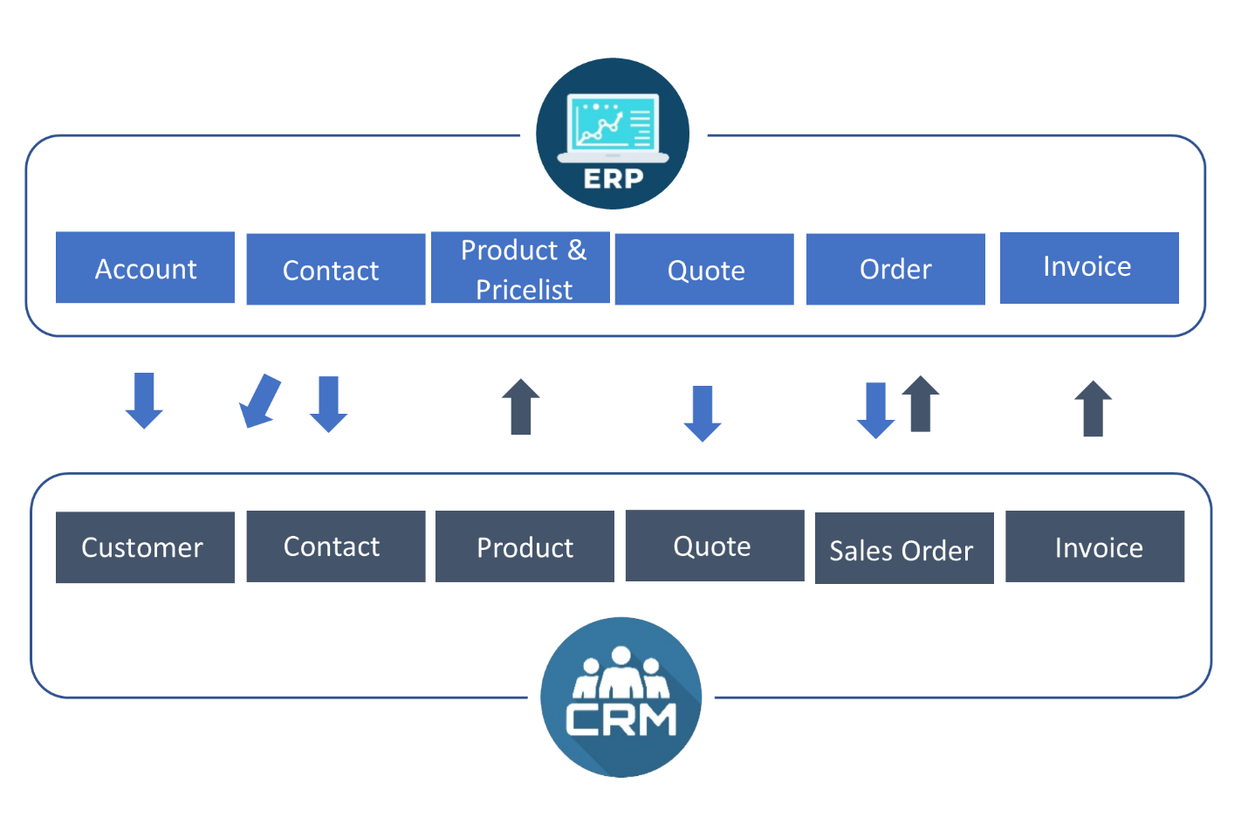
Source: neosalpha
ERP and CRM systems are essential to your business’s day-to-day operations. However, even if you’ve chosen the ERP and CRM tools that best fit your business needs, these systems alone can’t provide you with a comprehensive view of your company.

Managing several databases can result in a disorderly view of your business and the lack of ERP CRM integration can cause your business to have major blind spots, resulting in lost clients, missed opportunities, and waste of resources. Therefore, automating workflows through seamless integration of data between your ERP and CRM is a foundational requirement in order for your business’s operational processes to be efficient. When these systems are not integrated, it requires continuous and tedious manual management, which is prone to the risk of human error.

No company can afford to not have ERP CRM integration, especially startups that are targeting rapid growth with limited resources. This article is for you if you’re looking for the most efficient way as a startup to integrate your CRM and ERP with minimum resources and in the least possible time.

Benefits of ERP CRM Integration
With CRM and ERP system integration, you can:

- Get a comprehensive view of your clients; saving you time on data entry and improving client relations.
- Enjoy better reporting and analytics, allowing you to better predict purchasing habits and track customers’ relationships and history with your company.
- Provide your sales teams with valuable information when and where they need it, allowing them to close deals faster and more efficiently.
- Facilitate collaboration, making it easier for everyone to access the same information in real-time.
- Avoid data duplication and simplify data management by preventing the need to input the same information individually in each platform.

How to Achieve ERP CRM Integration
When it comes to integrating ERP and CRM, many startups know what the outcome of the automated workflows is, but they don't have the time or resources to figure out what is required to make it happen. On top of that, vendors provide complicated offers. There are no clear answers, and certainly no clear timeline.

Two of the most common ways to achieve ERP CRM integration are:

- Zapier integration – It is quick and easy, but more suitable for minor integrations.
- API integration – APIs depend on developers, requiring extensive development and code that needs to be maintained and updated. Plus, new integrations will need to be created as your operation grows.

That’s why these two options are not sustainable.

So how do you effectively integrate your CRM and ERP? This is where an iPaaS can help.

An iPaaS (or Integration Platform as a Service) is a software platform dedicated specifically to creating and managing integration applications. It is hosted in the cloud, and end-users can access it on a contract basis. Here’s why using an iPaaS to integrate your CRM and ERP systems is a good option for growing startups:

- You can collect valuable data and business process information from integrated ERP and CRM while securing and storing them offsite.
- There’s no need for manual upgrades and software maintenance.
- iPaaS tools support any type of user, data, and integration pattern, maximizing flexibility and scalability.
- You can enjoy better integrations in a shorter time, with increased scalability, reduced complexity, and lower integration costs.

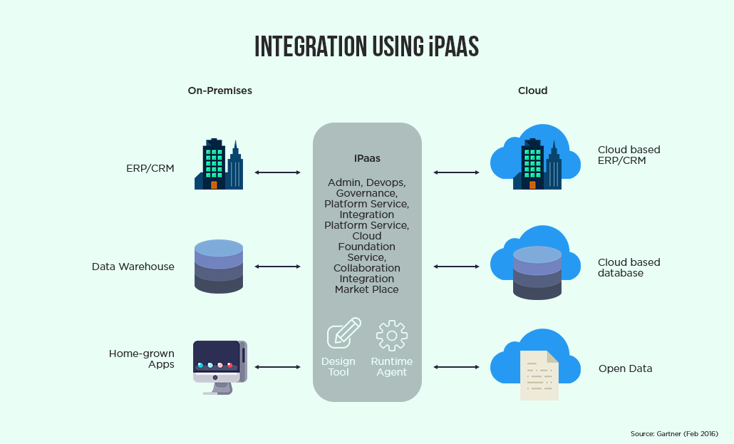
Source: ClarionTech

iConduct: The Best iPaaS for ERP CRM Integration

iConduct is an iPaaS that specially caters to your startup’s needs before or in the rapid growth phase. Its biggest advantages are speed and cost. Unlike other platforms, it is much more affordable for young startups that are working with limited resources.

Here’s what makes iConduct truly stand out as a reliable iPaaS tool for ERP CRM integration:

- Guidance – We offer integration architecture consultation.
- Efficiency – Implementation is on us. All other iPaaS vendors offer licenses only. You then will have to find a third-party integrator to set it up for you.
- Time – You are fully operational within 30 days.
- Transparent, Affordable Pricing – There are no hidden fees. Other iPaaS vendors offer tricky licenses for their software, loaded with surprise fees.
- Adjustable – Your needs are rapidly changing. iConduct scales with your business, empowering your digital operation for growth.
- Service - We are there when you need us, and it's included in the pricing.

With iConduct, now it’s possible to integrate your ERP and CRM in no time with minimum effort, and at an affordable and transparent price. Request a free demo!

