How to Integrate Legacy Systems
As companies experience growth and expansion, they find it challenging to integrate their legacy systems with new technologies, web and mobile apps, as well as in the cloud. Legacy systems are old, inflexible technologies implemented to resolve previous business challenges. Due to their long lifespans, these systems tend to be fragile, outdated, and difficult to integrate with new cloud and web-based services.

So why do companies still use legacy systems? That’s because replacing legacy systems is an extensive, expensive, and quite a risky process. It also requires an excessive amount of developer retraining, and doesn’t take into consideration the future needs of a business. No matter which way businesses turn, they seem to be stuck, unable to find an ideal solution for their legacy systems.

In this article, we look at how IConduct platform offers a solution to efficiently file sync from your legacy software to modern cloud-based systems, so that you can benefit from the latest technologies while unlocking the value of the data stuck in your legacy systems.

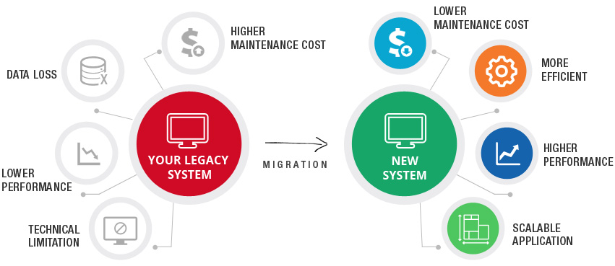
Source: AllianceTek

Challenges Associated with Legacy Systems

Working with legacy systems can present several challenges for businesses, and it constrains them from moving toward digital transformation. Some of these challenges include:

- Legacy software operates on legacy hardware, and maintaining such hardware can quickly become costly. Moreover, legacy software is unlikely to be run on newer hardware.
- Maintaining, improving, and expanding legacy systems can be difficult. At times, companies do not have the essential documentation for system changes or overall system architecture.
- Working with legacy systems needs a lot of patching. Often, these patches aren’t documented adequately.
- Legacy systems may have vulnerabilities that can put companies at risk of being compromised by attackers.


Source: intivix

The Need for Legacy System Integration
As mentioned above, legacy systems remain in use by businesses because their replacement or redesign is costly, risky, and complex. However, these systems can cause a huge loss in terms of business continuity if the systems fail or get attacked.

Moreover, not many engineers have the experience of working with legacy systems such as mainframe systems. As they have been coded in “old code”, mainframe systems necessitate knowledge of legacy programming languages (for instance, COBOL).

Working with legacy systems alone slows down innovation in companies. It can also increase the time to market (TTM) of new initiatives. Plus, there is a lot of data concealed in legacy systems that, because of the lack of integration, often remains unutilized.

Therefore, companies have to opt for legacy system integration in order to make the most use of their old systems while leveraging new technologies such as artificial intelligence, machine learning, IoT, and SaaS platforms.

How IConduct Can Help With Legacy System Integration
When using modern software, APIs provide an economical and fast solution for syncing and integrating between systems. However, in the case of custom legacy systems, integration becomes challenging because of their proprietary and outdated functions that do not expose APIs. Moreover, point-to-point integration is insufficient if there are more than one integrations.

How to integrate legacy systems efficiently? This is where IConduct can help!

The IConduct platform gives you options for integrating data from legacy systems, either by using files or connecting to the database and other techniques, to access the data, manipulate it to be compatible and then integrate it to any cloud-based services securely without depending on an API. The platform supports all enterprise, legacy, and cloud-based business applications, and eliminates coding on both the source and target application.

With a secured agent, full in-memory data handling, and active transaction monitoring, IConduct’s integration platform delivers the best performance, ultimate security, and the confidence that all applications are communicating seamlessly and securely. Get in touch to request a free demo.

